Student’s Name
Institution
Date
Maths Questions
Convert each of the angle measures form degree to radians. Round your answers to the correct number of the significant figures
Solutions
A circle has 360 degrees which is equivalent to 2π radians
Therefore, 360º = 2π radians
- 15º
If 360º = 2π radians
15º =x π radians
$$=(15° × π 180°$$
$$= 0.90833333333π rad$$
$$=0.26 radians$$

(2) 163.5º
If 360º = 2π radians
163.5º = x π radians
x =$163.5° × π 180°$
$$x= 0.90833333333π rad$$
$$x=2.85$$

(3) 48.6 º
If 360º = 2π radians
=48.6º = x π radians
x=$48.6° × π 180°$
$$x= 0.90833333333π rad$$
x$=0.85$

(4) 242.35°
If 360º = 2π radians
=242.5º = x π radians
x=$242.35° × π 180°$
x$=0.90833333333π rad$
$x=4.23$

(5) 338.6°
If 360º = 2π radians
338.6º = x π radians
x=$338.6° × π 180°$
x$=0.90833333333π rad$
$x=5.91$
Convert each of the angle measures from radians to degrees. Round to the nearest correct number of the significant figure

(6) 2.15
If 2π radians =360º
1 radian= 180/ π
=2.15×180°/π
= 123.19°

(7) 1.14
If 2π radians =360º
1 radian= 180/ π
=1.14×180°/π
= 65.32°

(8) 4.084
If 2π radians =360º
1 radian= 180/ π
=4.08484×180°/π
= 234.04°

(9) $=\frac{4π}{3}(keep 5 significant figures$
If 1 radian= 180/ π
=4/3π×180°/π
= 240°

(10) 0.25
If 1 radian= 180/ π
=0.25×180°/π
= 14.32°

Each point is on the terminal side of an angle, θ, in standard position. Find the six trigonometric functions of the angle associated with each of these points. Leave your answers as fractions reduced to lowest terms.

(11) (4, 2)
Let x=4
Let y=2
Let r= the length of a line segment drawn from the origin to the point:
r=√(x2+y2)
r=√(4²+2²)
r=√20

Sine =2/√20
Cosine =4/√20
Tangent =2/4
Cotangent =4/2=2
Secant =√20/4
Cosecant =√20/2
(12) (1,-3)
Sine =-3/√10
Cosine =1/√10
Tangent =3/1
Cotangent =3/1=3
Secant =√10/3
Cosecant =√10

(13) (-5, √11)

Explanation:
Let x=−5
Let y=√11
Let r= the length of a line segment drawn from the origin to the point:
r=√x2+y2
r=√(−5)2+√11²
r=√36=6

Sine =-√11/6
Cosine =-5/6
Tangent =-√11/5
Cotangent =-5/√11
Secant =6/4
Cosecant =-6/5

(14) (-√13, -6)
r=√205
Sine =-6/√205
Cosine = -√13/√205
Tangent =-6/√13
Cotangent = √13/6
Secant =√205/√13
Cosecant =-√205/6

Determine the point p(x,y) on the terminal side of an angle, θ, in standard position from the information given. Then, determine the value of the 6 trigonometric functions. Leave your answers as fractions reduced to lowest terms

(15) x=3, y>0, r=5
y=√(5²-3²)
y=4
Point p (4,3)
r=5

Value of the trigonometric functions

Sine =3/5
Cosine =4/5
Tangent =3/4
Cotangent =4/3
Secant =5/4
Cosecant =5/3

(16) 𝑥 = -20, 𝑦 < 0, 𝑟 = 29
y=√(-29² - -20²)
y= -21
point p (x,y) = (-21,-20)
r=29

Value of the trigonometric functions
Sine = -21/29
Cosine =-20/29
Tangent =21/20
Cotangent =20/21
Secant =29/21
Cosecant =29/20

(17) 𝑥 < 0, 𝑦 = 5, 𝑟 = 30
x=√(30² - 5²)
x=-5√35
point p (x, y) = (5,- 5√35)

Value of the trigonometric functions
Sine = - 5√35/30
Cosine =5/30=1/6
Tangent =- 5√35/5
Cotangent =5/- 5√35
Secant =30/- 5√35
Cosecant =30/5 =5

(18) 𝑥 > 0, 𝑦 = -9, 𝑟 = 15
x=√(15² - 9²)
x=12
point (x,y) = (-9, 12)
r=15

Value of the trigonometric functions
Sine = 12/15=4/5
Cosine =-9/15=3/5
Tangent =-12/9=-4/3
Cotangent =9/12=3/4
Secant =15/-9=-5/3
Cosecant =15/12=5/4

Use a calculator to determine the values of each of the indicated trigonometric function. Round your answers to the correct number of significant figures

(20) cos(314°) = 0.69466
(21) tan(1.35) = 4.45522
(22) sec(19.15°) = 1.05857
(23) csc(0.43) = 2.39882
(24) cot(1.21) = 0.37731
(25) sin(1.38) = 0.98185
(26) cos(3.20) = -0.99829
(27) tan(126.3°) =-1.36134
(28) sec(2.41) = -1.34388
(29) csc( 213.8°) = -1.79760
(30) cot(305°) = -0.70020
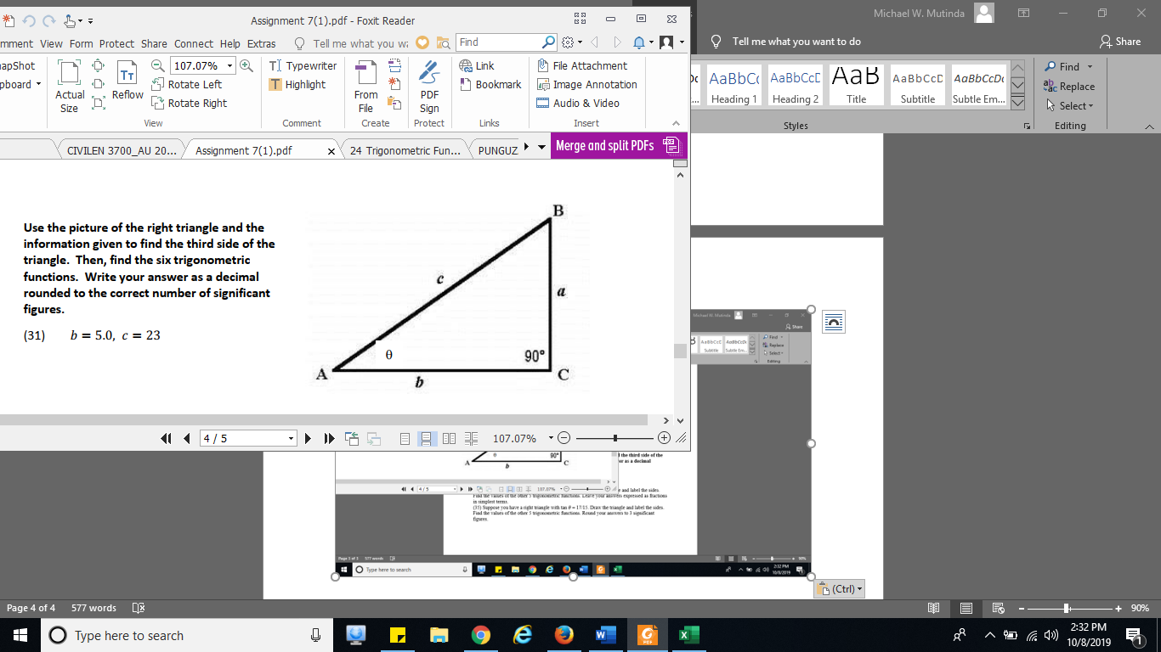
Use the picture of the right triangle and the information given to find the third side of the triangle. Then, find the six trigonometric functions. Write your answer as a decimal rounded to the correct number of significant figures.
(31) 𝑏 = 5.0, 𝑐 = 23
a = √(23²-5²)
a=√504
Prime factorization 504 =2*2*2*3*3*7
a=√(2*2*2*3*3*7)
a=6√14
a=22.4494

Sine = 22.4494/23=0.9761
Cosine =5/23=0.2174
Tangent =22.4494/5=4.4899
Cotangent =5/22.4494=0.22272
Secant =23/22.4494=1.0245
Cosecant =22.4494/23=0.9761

(32) 𝑏 = 2.10, 𝑐 = 8.00
a = √(8²-2.10²)
a=√59.59
a=7.7195

Sine = 7.7195/8=0.9649
Cosine =2.10/8=0.2625
Tangent =7.7195/2.10=3.676
Cotangent =2.10/7.7195
Secant =8/2.10=0.27204
Cosecant =8/7.7195=1.0363

(33) a= 1.4, 𝑏 = 2.1
c= √(1.4²+2.1²)
c=√ 6.37
c=2.52388

Sine = 1.4/2.52388=0.5547
Cosine =2.1/2.52388=0.8321
Tangent =1.4/2.1=0.6667
Cotangent =2.1/1.4=1.5
Secant =2.52388/1.4=1.80277
Cosecant =2.52388/2.1=1.2018

(34) Suppose you have a right triangle with cos 𝜃 = 3/5. Draw the triangle and label the sides. Find the values of the other 5 trigonometric functions. Leave your answers expressed as fractions in simplest terms.

B
4 517 5

C 3 A
3

Solution
b=√(5²-3²)
b=4

Sine = 4/5
Cosine =3/5
Tangent =4/3
Cotangent =3/4
Secant =5/4
Cosecant =5/3

(35) Suppose you have a right triangle with tan 𝜃 = 17/15. Draw the triangle and label the sides. Find the values of the other 5 trigonometric functions. Round your answers to 3 significant figures.

A

15

C 17 B

solution
c=√(15²+17²)
=√514
Sine = 15/√514
Cosine =17/√514
Tangent =17/15
Cotangent =15/17
Secant =√514/15
Cosecant =√514/17

